Task 1: This Task aims to teach you the construction-demolition functions and the composition of classes.

Implement in C ++ a simulation of students arriving in a school building in the morning and entering the classroom.

The school building consists of three floors, a courtyard and a staircase. Each term consists of six classes and a corridor. Each class has a maximum of C_{class} students and a teacher. If the teacher is in the classroom, no other student can enter
in this class. Each student is characterized by his name, the details of his class (serial number and class number) as well as an indication of where he is (courtyard, staircase, hallway, classroom, outside the school building). The information of the teacher is his name, the data of his class as well as an indication if he is in it. Both the courtyard and the stairwell and the corridors of the floors have a maximum capacity, C_{yard}, C_{stair} and C_{corr}, respectively and at any time there may be students in them. All corridors have the same capacity.

Students enter the school building (enter), entering one by one those who can enter. Then students come out of the courtyard and enter the stairwell, those who fit in it. Then, students come out of the stairwell and enter the floors of their classrooms, those who fit in each of them.

A student enters the school building (enter), typing his name accompanied by the message "... enters school!" and entering the courtyard, if it fits.

- a student enters the courtyard (enter) by typing his name accompanied by the message "... enters schoolyard!" and including the student in the courtyard students. The first student to be able to leave the courtyard, printing his name accompanied by the message "... exits schoolyard!", Is removed from the students who are in it and becomes available in the environment that caused the exit.

- a student enters the staircase (enter) by typing his name accompanied by the message "... enters stairs!" and including the student in the staircase students. A student leaves the staircase (exit), typing his name accompanied by the message "... exits stairs!", Removing him from his students and becoming available in the environment that caused the exit.

A student enters a term (enter), typing his name accompanied by the message "... enters floor!" and entering the hallway of the mountain, if it fits.

A student enters the corridor (enter) typing his name accompanied by the message "... enters corridor!" and is added to the students of this corridor. A student exits the corridor (exit), printing his name accompanied by the message "... exits corridor!", Is removed by his students and becomes available in the environment that caused the exit.

A student enters his class (enter), if his teacher has not entered it. Entering the classroom, his name is printed and the message "... enters classroom!" and is added to students in this class.
We consider a teacher to be instantly placed in his / her classroom (place) in the school building — they are not preceded by the individual steps of entering the building for them. This is done by placing it (place) in the term to which its class belongs. The latter is done by placing it in place.

We can print the school building by printing the message "School life consists of:" and then by printing the courtyard, the air-conditioning room and the floors. We print the courtyard (print), printing the message "People in schoolyard are:" and printing the students who are in it. We print the staircase (print), printing the message "People in stairs are:

- and printing the students who are in it. We print a term, print the message "Floor number" f loor number "contains:" and print the aisle and the classes in it. We print the corridor (print), printing the message "People in corridor are:" and printing the students who are in it. We print a class by printing the message "People in class" class number are: "and printing the students and the teacher in it. We print a student by printing his name. a teacher (print) simply prints before the message "The teacher is:".

When a school building is created, the message "A New School has been created!" and the capacities of the classrooms, the courtyard, the stairwell and the corridors are determined. Corresponding messages are printed when the courtyard, stairwell, floors, corridors and classrooms are created. The courtyard, the staircase and the classrooms are initially empty.

When the school building is destroyed, the message "A School to be destroyed!" Is printed. Corresponding messages are printed when the courtyard, staircase, floors, corridors and classrooms are destroyed.

When a new student is created, it is initialized with its data and the indication that it is outside the school building. Also, the message "A New Student has been created!", His name and the details of his class are printed. When a student is destroyed, the message "A Student to be destroyed!" Is printed, its details and where it is located.

When a new teacher is created, it is initialized with its data and the indication that it is out of class. Also, the message "A New Teacher has been created!", Its name and the details of its class are printed. When a teacher is destroyed, the message "A Teacher to be destroyed!" Is printed. and its data.

Implement the above, through the appropriate classes, defining the data members that are needed and the member functions that implement the above behavior. Also implement a main function in which:

- Create a school building.

- To create his students and teachers

- Repeat the following procedure until either all students have entered their classrooms or no other students can enter

(aʹ) Students enter the school building in random order

(bd) Choose at random whether teachers will be placed in their classrooms — in case of a positive result, the selection of teachers for placement will again be random
4. Print the school building.

The C_{class}, C_{yard}, C_{stair} and C_{corr} be given from the command line, in that order.

Task 2: Implement in C ++ a simulation of the movement of kindergarten students between classes. We assume that each section has the same number of boys and girls unless it is an odd number so it is one more than the men or not.

At this station, in order not to create disorder, when the children of a department are about to move, they form a sequence of pairs. Considering that girls are quieter than boys (in the general case :)), couples are boy-girl. Also, the boy of the couple, in the corresponding position of the couples in front and behind him has girls (and a girl, respectively, boys). The sequence is characterized by the section number, e.g. whole. It is initialized, placing the students of the department in a suitable position.

When all the sections are to be moved, their sequences follow one another. You can see a picture of a sequence of two sections in Figure 1. If two sections have an odd number of students but the excess students are a boy-girl, then they enter the sequence of the first section as a pair.

However, disorders can occur. If individual children misbehave, they are confronted with others of the same Fleet who are randomly selected from their department sequence. If it is one or two couples, the same goes for the children who make them up. However, if there are more pairs and the pairs are consecutive, the exchange takes place between students from different departments and so they are divided into other departments. If the naughty couples are scattered, it is enough to alternate their students with students of the next section. Each section is characterized by a degree of disorder of its students. For each student transfer, the counter of the department to which the student who caused it belongs increases by one degree. If students were transferred between classes, the increase is doubled. Initially,

Each student is characterized and initialized by his name, department and Flea.

It is possible to print these data.

It is possible to print the sequence of sections, printing their sequences. A section sequence is printed by printing the pairs that make it up. A pair is printed, printing its position in the sequence and its students. When printing the segment sequence, if the degree of disorder is below a percentage

of the students of the department, T_{quiet}, to print the message "What a quiet class!". If it is above another (higher) percentage, T_{messy}, print the message "What a
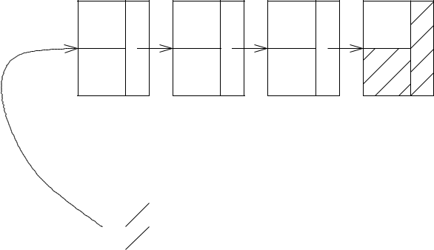

 |  |  | 1111111100000000 |  | 1111111100000000
1111111100000000 |  | 1111111100000000 | 1111111100000000 |  | 1111111100000000
1111111100000000 |  | 1111111100000000 | 1111111100000000 |  | 1111111100000000
1111111100000000 |  | 1111111100000000 | 1111111100000000 | S9 | 1111111100000000 | S13
1111111111111111000000000000000000 |  | 1111111111111111000000000000000000 | 1111111100000000 | S9 | 11100000000S1111 | S13
 |  |  | S7 | S9 | 1111111100000000 | S13
S1 | S3 | S5 | 1111111100000000 |  | 11111110000000
S1 | S3 | S5 | 11111110000000 |  | 11111110000000
111000000001111 |  | 1111111100000000 | 1111111100000000 |  | 1111111100000000
1111111100000000 |  | 1111111100000000 |  | 1111111100000000
1111111100000000 |  | 1111111100000000 |  | 1111111100000000
1111111100000000 |  | 1111111100000000 |  | 1111111100000000
11111110000000 | 1111111100000000 | 11111110000000 | S8 | 1111111100000000 | S12
 | 1111111100000000 |  | S8 | 11100000111100 | S12
 | 1111111100000000 |  | S8 | S10 | S12
S2 | 1111111100000000 | S6 |  | 1111111100000000
S2 | S4 | S6 |  | 1111111100000000
 | 1111111100000000
 | 1111111100000000 |  |  | 1111111100000000
 | 1111111100000000 |  |  | 11111110000000
 | 1111111100000000
 | 11111110000000
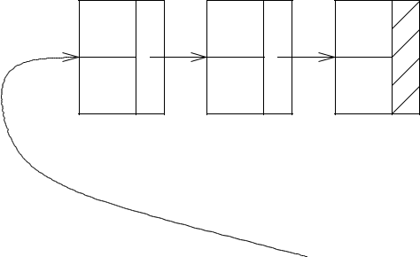

Class1 |  |  |  |  | Class2

Figure 1: An example of a two-part sequence
mess! ". In any other case, print the message," Please, be quiet! ". The percentages should be parameters of the simulation and should be given from the command line.

Implement the above through appropriate classes, where needed, which are related to functions that accomplish the procedures described.

Also implement a main function in which:

- Create a set of students belonging to K departments

- Create sequences for the sections to which they belong

- To create the sequence of sections

- Print this sequence

- For L's Hours, select a random number of random children to make a mess. For each child, print his / her details, take the necessary actions and print the sequences that were affected by these actions

- Finally, print the sequence of sections as it will be configured.

The parameters K and L as well as the percentage thresholds, T_{quiet} and T_{messy}, to be given from the command line, in that order.

Note: In the implementation of Tasks, the only type of library type that you are allowed to use is the string type.

